**Interfacing a Seven Segment Display**

**Aim:**

To write an ASM for interfacing a Seven Segment Display using MCU 8051 IDE.

**Procedure**

//Write the Procedure here

**CODE**

;ALP FOR SEVEN SEGMENT DISPLAY

ORG 0000H

LJMP 100H ;BYPASS IVT

ORG 50H

DB 3FH, 6H, 5BH, 4FH, 66H, 6DH, 7DH, 7H, 7FH, 6FH, 77H, 7CH, 39H, 5EH, 79H, 71H

;MAIN PROGRAM

ORG 100H

START: MOV R7, #16 ;COUNTER TO COUNT 16 HEX NUMBERS

MOV P0, #0 ; PORT 0 AS OUTPUT PORT

MOV DPTR, #50H ;POINTER IS LOADED WITH STARTING ADDRESS OF HEX NUMBERS

BACK: CLR A

MOVC A, @A+DPTR

MOV P0, A

INC DPTR

ACALL DELAY

DJNZ R7, BACK

SJMP START

;SUBROUTINE FOR SMALL DELAY

DELAY: MOV R1, #5

WAIT1: MOV R2, #250

WAIT: DJNZ R2, WAIT

DJNZ R1, WAIT1

RET

END

**Execution Steps (*given for understanding – do not write this in record notebook)***

1. Click on Virtual HW
2. Open LED Display
3. Go to Settings
4. Choose Common Electrode 🡪 Common Cathode
5. Choose Color 🡪 Select any color to display in the Seven Segment
6. Choose Port 0 🡪 Bit 🡪0, Port 0 🡪 Bit 🡪1 …… Port 0 🡪 Bit 🡪7
7. Turn ON the LED Display
8. Simulate
9. Animate
10. Observe the LED Display
11. Print all the Seven Segment Display

**Output**

**Initial Setup**

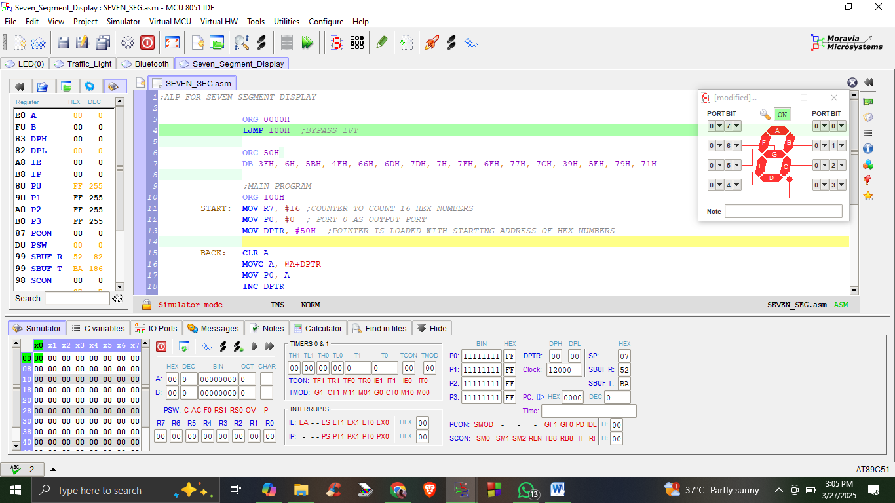

**Number 0**

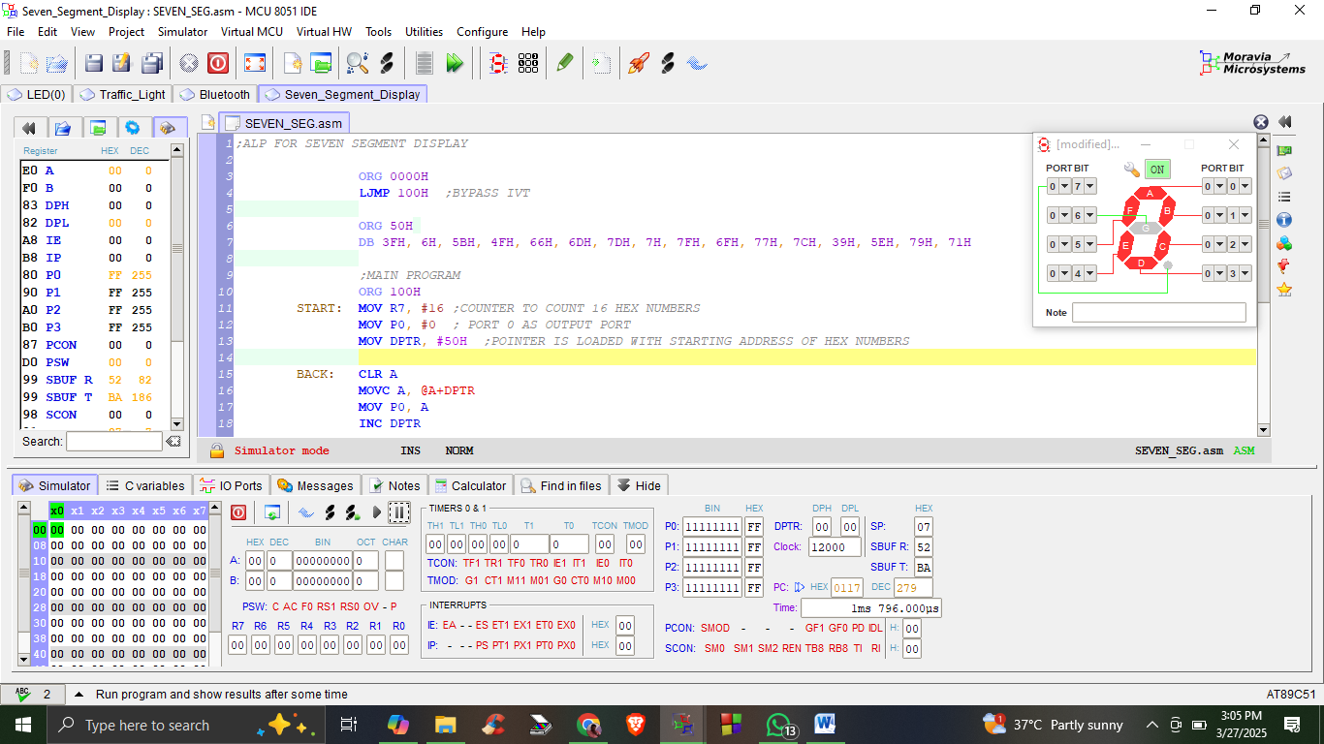

**Number 1**

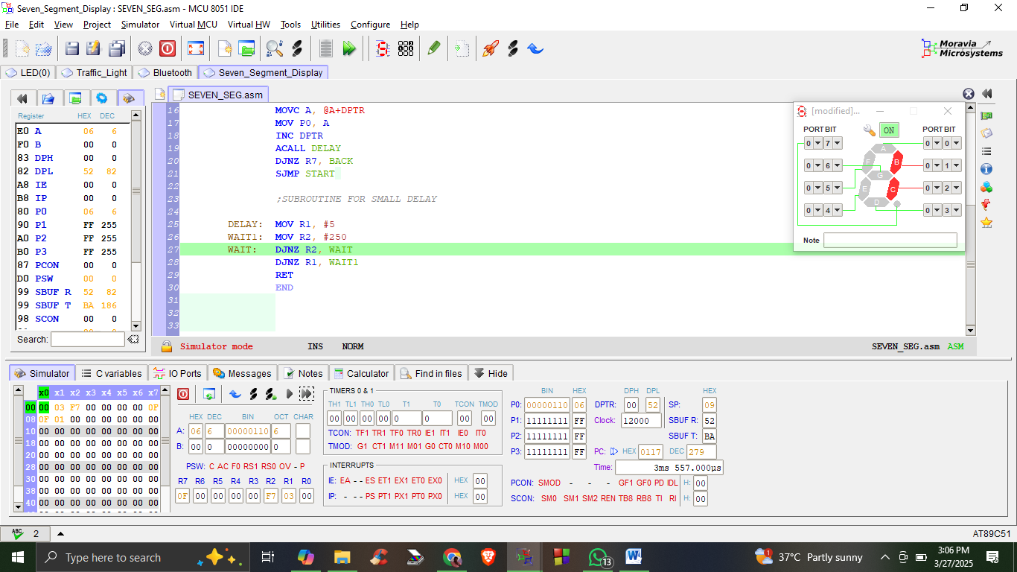

**Number 2**

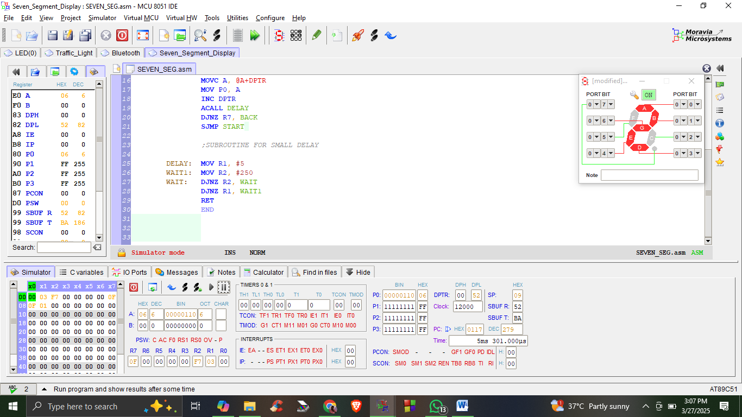

Display the output of all seven segments and finally write the result.